Module 7- Final Project Reflection

James Piggot
Southern New Hampshire University
CS:330: Comp graphic and Visualization
Professor Thomas Gerlach
4/19/2026

Justifying Development choices
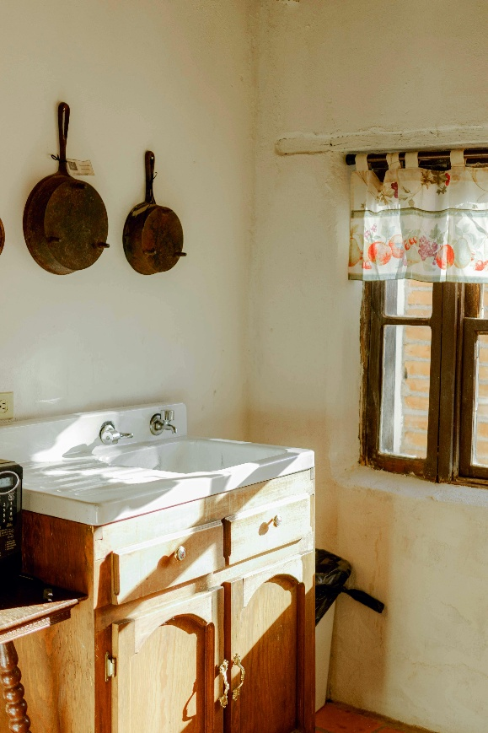

My primary goal in this 3D scene was to create a copy of the rustic kitchen pictured in my reference image. Within this approach, I had hoped to demonstrate an understanding of geometry, texturing, and lighting. Originally, the choice for this kitchen was a simple one; while complex on the surface, the majority of the image can be easily broken down into geometric shapes and parts when approaching the final project. It also offered the necessary amount of shapes to meet the final project’s requirements.
We were required to include at least four objects, so to do this, I implemented a room, a complex sink assembly, hanging pans, and a waste bin. For complex objects, we can start first with the cabinet and sink assembly. This is a massively complex item; it not only includes a box for the main shape, but it also needs a plane for the countertop, cylinders for handles and faucets, and then even more planes and spheres to create the shape and aspect of drawers. However, the scene itself was primitive when broken down into 3D shapes.
To handle "whitewash" exposure caused by the strong point lights, I implemented a custom material library logic in OBJECT_MATERIAL. This allowed me to manually calibrate the ambientStrength and specularColor for every object individually as needed. For instance, the walls use a specific clay material with a low diffuseColor to prevent the texture from becoming blown out, while the marble countertop used a separate material to ensure the high shininess could remain.

Navigation and Camera Setup
For navigation and camera control, I programmed a standard WASD key control with Q and E to handle vertical up and down navigation. To add a bit more control to all of this, I introduced pitch and yaw mouse control to make the experience feel more natural and realistic, as this is the same format most users are accustomed to from gaming or other software.
I integrated movement speed directly into the mouse scroll wheel to allow for nuanced control. While ensuring I met the requirements for orthographic and perspective views, I created a toggle that switches between the two perspectives instantly. To wrap this all into a neat package for the user experience, I introduced a HUD to explain the camera commands to the user. To avoid distracting from the graphic experience, this information appears directly in the window's title bar instead of on the actual rendering screen.

Custom Functions and Modularity
Within my code, I used a variety of custom functions to support the flow and readability of the program. For example, I used selectMaterial and SetupSceneLights to allow for an scalable number of materials and lights that can be expanded for future use. Furthermore, I organized my development into several modular functions. Every part of my script was reduced to its own function except in rare cases where it made sense to keep them integrated.
Specifically, I broke down the walls, windows, and pans into their own original functions, while the sink itself was managed by a different function. This allowed for better readability and made it easier to adjust the code when fixing issues with logical positioning in the scene. I sorted these functions by their major purpose and included only the logic within each that was relevant to that specific component.

References
Alcántara, A. (n.d.). Photo of vintage kitchen. Pexels. https://www.pexels.com/photo/photo-of-vintage- kitchen-11483728/

